EXPERIMENT NO. 1

Write SQL command to create the student table (e.g. STUD_10) having structure ROLL_NO, NAME_OF_THE_STUDENT, CLASS (MBA/MCA), GENDER (M=MALE, F=FEMALE), CENTER (KARAD, KOLHAPUR, SANGALI, PUNE), YEAR, NAME_OF_THE_LAST_COLLEGE_ATTENDED (YMIM/YC/KCT etc.).

CREATE TABLE STUDENT_003

(

ROLL_NO NUMBER(2),

NAME CHAR(15),

CLASS CHAR(10),

GENDER CHAR(10),

CENTER CHAR(25),

YEAR NUMBER(5),

LCOLLEGE CHAR(15)

);

DESCRIBE STUDENT_003;

**Output :**

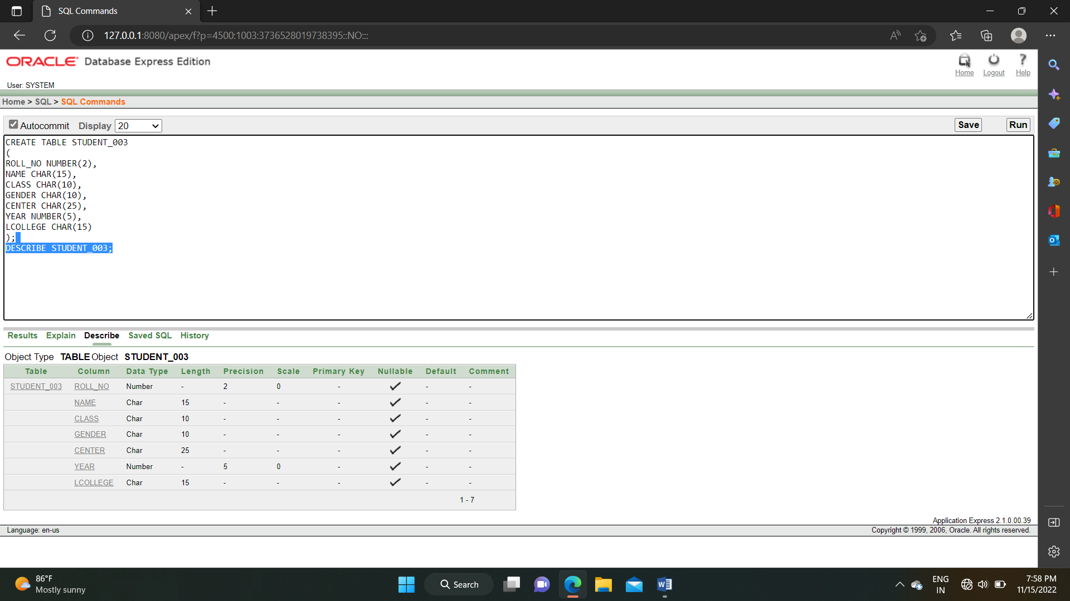

EXPERIMENT NO. 2

Write SQL command to add 18 record of different centers with different classes.

INSERT INTO STUDENT_003(ROLL_NO,NAME,CLASS,GENDER,CENTER,YEAR,LCOLLEGE)

VALUES(1,'A.J.GOKHALE','MCA','FEMALE','SATARA','2022','SGM');

INSERT INTO STUDENT_003(ROLL_NO,NAME,CLASS,GENDER,CENTER,YEAR,LCOLLEGE)

VALUES(2,'S.V.DESHMUKH','BCA','FEMALE','KOLHAPUR','2022','YMIMK');

INSERT INTO STUDENT_003(ROLL_NO,NAME,CLASS,GENDER,CENTER,YEAR,LCOLLEGE)

VALUES(3,'J.B.PATIL','MCA','MALE','SATARA','2021','VC');

INSERT INTO STUDENT_003(ROLL_NO,NAME,CLASS,GENDER,CENTER,YEAR,LCOLLEGE)

VALUES(4,'A.S.NIKAM','MCS','FEMALE','KARAD','2022','YMIMK');

INSERT INTO STUDENT_003(ROLL_NO,NAME,CLASS,GENDER,CENTER,YEAR,LCOLLEGE)

VALUES(5,'S.T.JADHAV','MCA','MALE','KOLHAPUR','2023','SGM');

INSERT INTO STUDENT_003(ROLL_NO,NAME,CLASS,GENDER,CENTER,YEAR,LCOLLEGE)

VALUES(6,'J.S.PAWAR','BCA','FEMALE','SATARA','2022','YMIMK');

INSERT INTO STUDENT_003(ROLL_NO,NAME,CLASS,GENDER,CENTER,YEAR,LCOLLEGE)

VALUES(7,'S.M.PATIL','MCA','MALE','KARAD','2021','KBPS');

INSERT INTO STUDENT_003(ROLL_NO,NAME,CLASS,GENDER,CENTER,YEAR,LCOLLEGE)

VALUES(8,'A.S.SHARMA','MCS','FEMALE','KOLHAPUR','2022','YMIMK');

INSERT INTO STUDENT_003(ROLL_NO,NAME,CLASS,GENDER,CENTER,YEAR,LCOLLEGE)

VALUES(9,'U.T.PATIL','BCS','MALE','SATARA','2022','SGM');

INSERT INTO STUDENT_003(ROLL_NO,NAME,CLASS,GENDER,CENTER,YEAR,LCOLLEGE)

VALUES(10,'K.L.THORAT','MCA','MALE','KARAD','2023','VC');

INSERT INTO STUDENT_003(ROLL_NO,NAME,CLASS,GENDER,CENTER,YEAR,LCOLLEGE)

VALUES(11,'K.D.KHABALE','MCA','FEMALE','SATARA','2021','YMIMK');

INSERT INTO STUDENT_003(ROLL_NO,NAME,CLASS,GENDER,CENTER,YEAR,LCOLLEGE)

VALUES(12,'D.K.SHEWALE','MCA','MALE','KARAD','2022','SGM');

INSERT INTO STUDENT_003(ROLL_NO,NAME,CLASS,GENDER,CENTER,YEAR,LCOLLEGE)

VALUES(13,'S.D.PATEL','BCA','FEMALE','KOLHAPUR','2022','YMIMK');

INSERT INTO STUDENT_003(ROLL_NO,NAME,CLASS,GENDER,CENTER,YEAR,LCOLLEGE)

VALUES(14,'D.M.BISTA','MCA','MALE','NEPAL','2021','YMIMK');

INSERT INTO STUDENT_003(ROLL_NO,NAME,CLASS,GENDER,CENTER,YEAR,LCOLLEGE)

VALUES(15,'S.V.NIKAM','BCA','FEMALE','KARAD','2022','SGM');

INSERT INTO STUDENT_003(ROLL_NO,NAME,CLASS,GENDER,CENTER,YEAR,LCOLLEGE)

VALUES(16,'N.D.WHEELER','MCA','FEMALE','NEW YORK','2023','YMIMK');

INSERT INTO STUDENT_003(ROLL_NO,NAME,CLASS,GENDER,CENTER,YEAR,LCOLLEGE)

VALUES(17,'J.M.SHARMA','BCS','MALE','KERALA','2022','SGM');

INSERT INTO STUDENT_003(ROLL_NO,NAME,CLASS,GENDER,CENTER,YEAR,LCOLLEGE)

VALUES(18,'P.S.SHINDE','MCA','FEMALE','SATARA','2022','YMIMK');

INSERT INTO STUDENT_003(ROLL_NO,NAME,CLASS,GENDER,CENTER,YEAR,LCOLLEGE)

VALUES(19,'Y.S.SHARMA','MCA','MALE','PUNE','2021','YMIM');

INSERT INTO STUDENT_003(ROLL_NO,NAME,CLASS,GENDER,CENTER,YEAR,LCOLLEGE)

VALUES(20,'K.S.SHARMA','BCA','FEMALE','MUMBAI','2022','SGM');

**Output :**

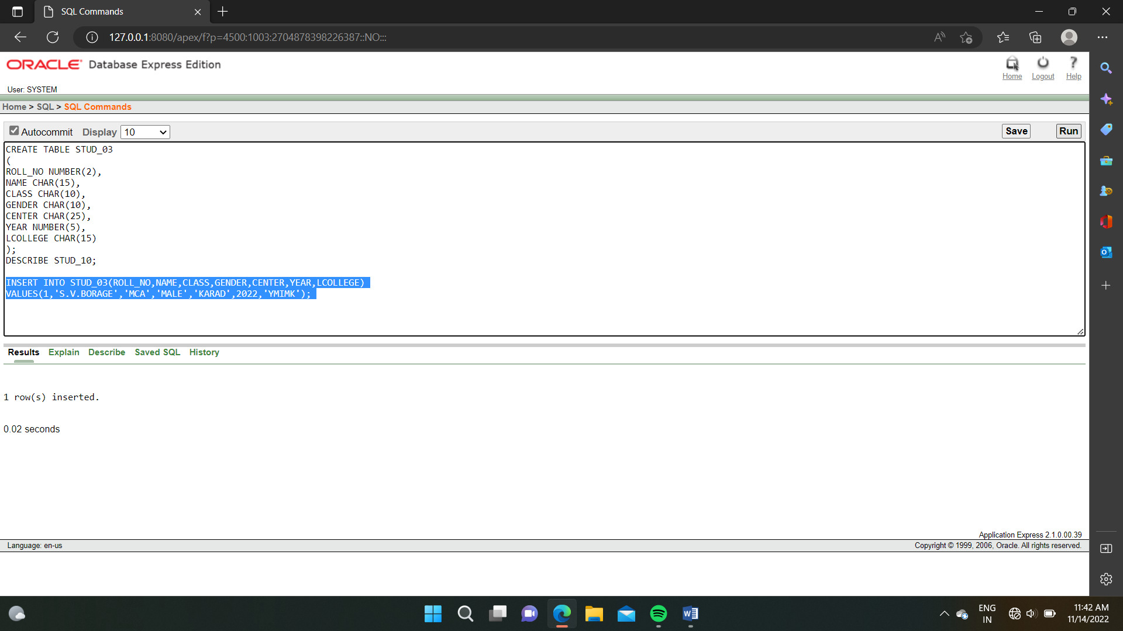

SELECT * FROM STUDENT_003;

**Output :**

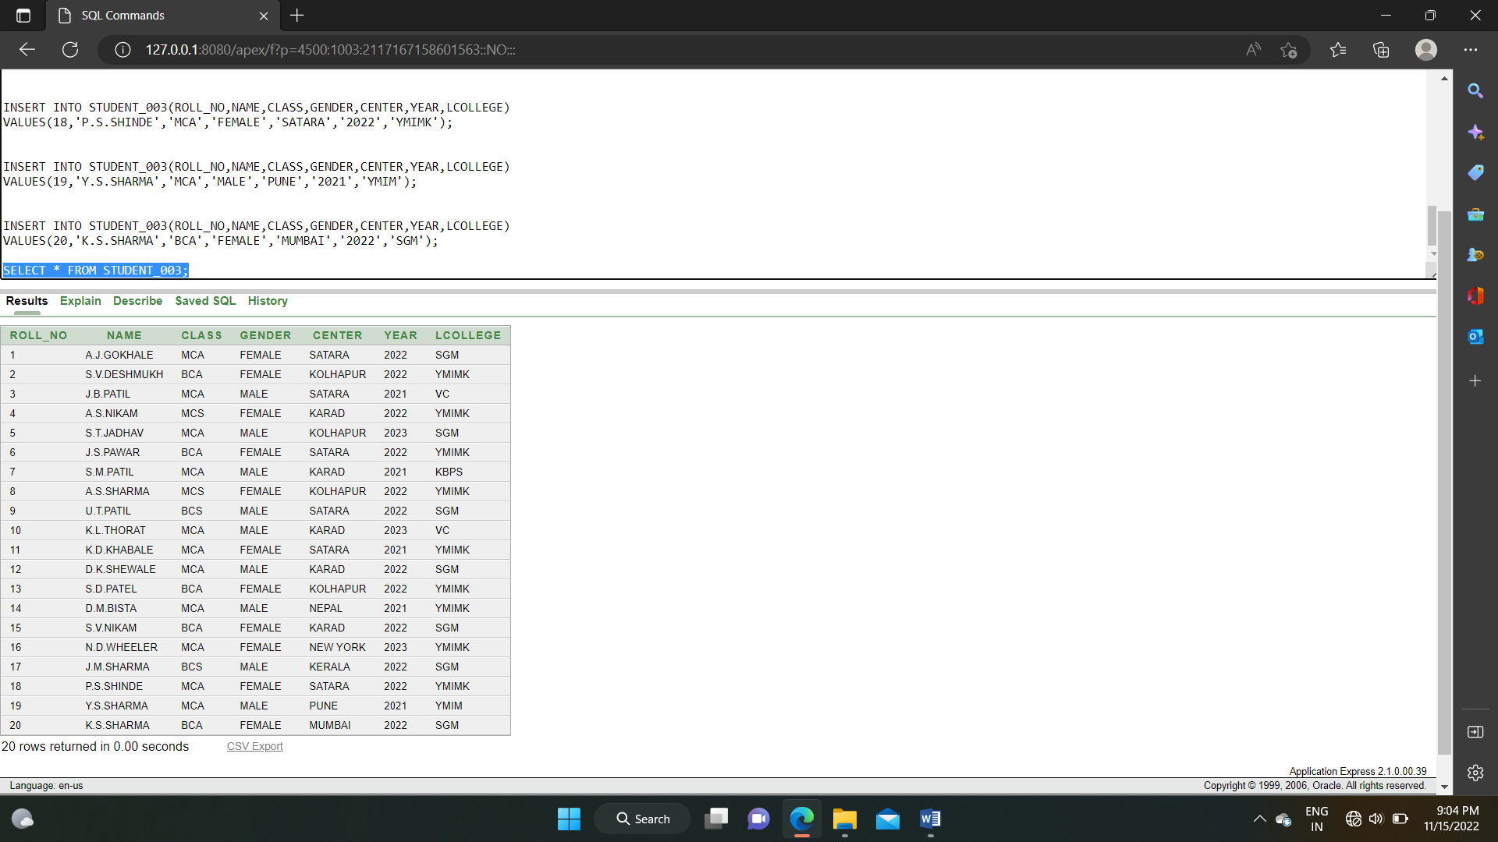

EXPERIMENT NO. 3

Implement UPDATE, DELETE SQL command by using Student_rollno table.

1. **UPDATE :**

UPDATE STUDENT_003

SET NAME = 'K.D.MEHTA', YEAR = 2022

WHERE ROLL_NO = 11

**Output :**

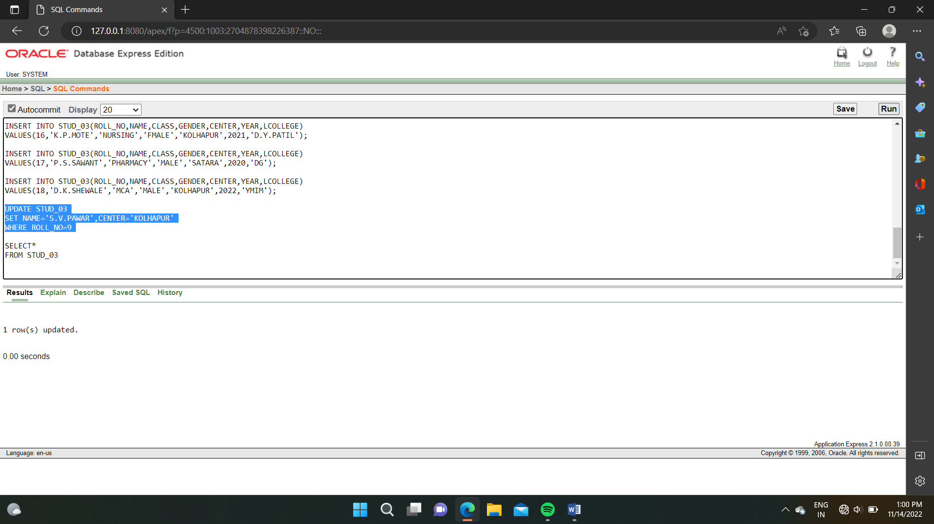

SELECT * FROM STUDENT_003

**Output :**

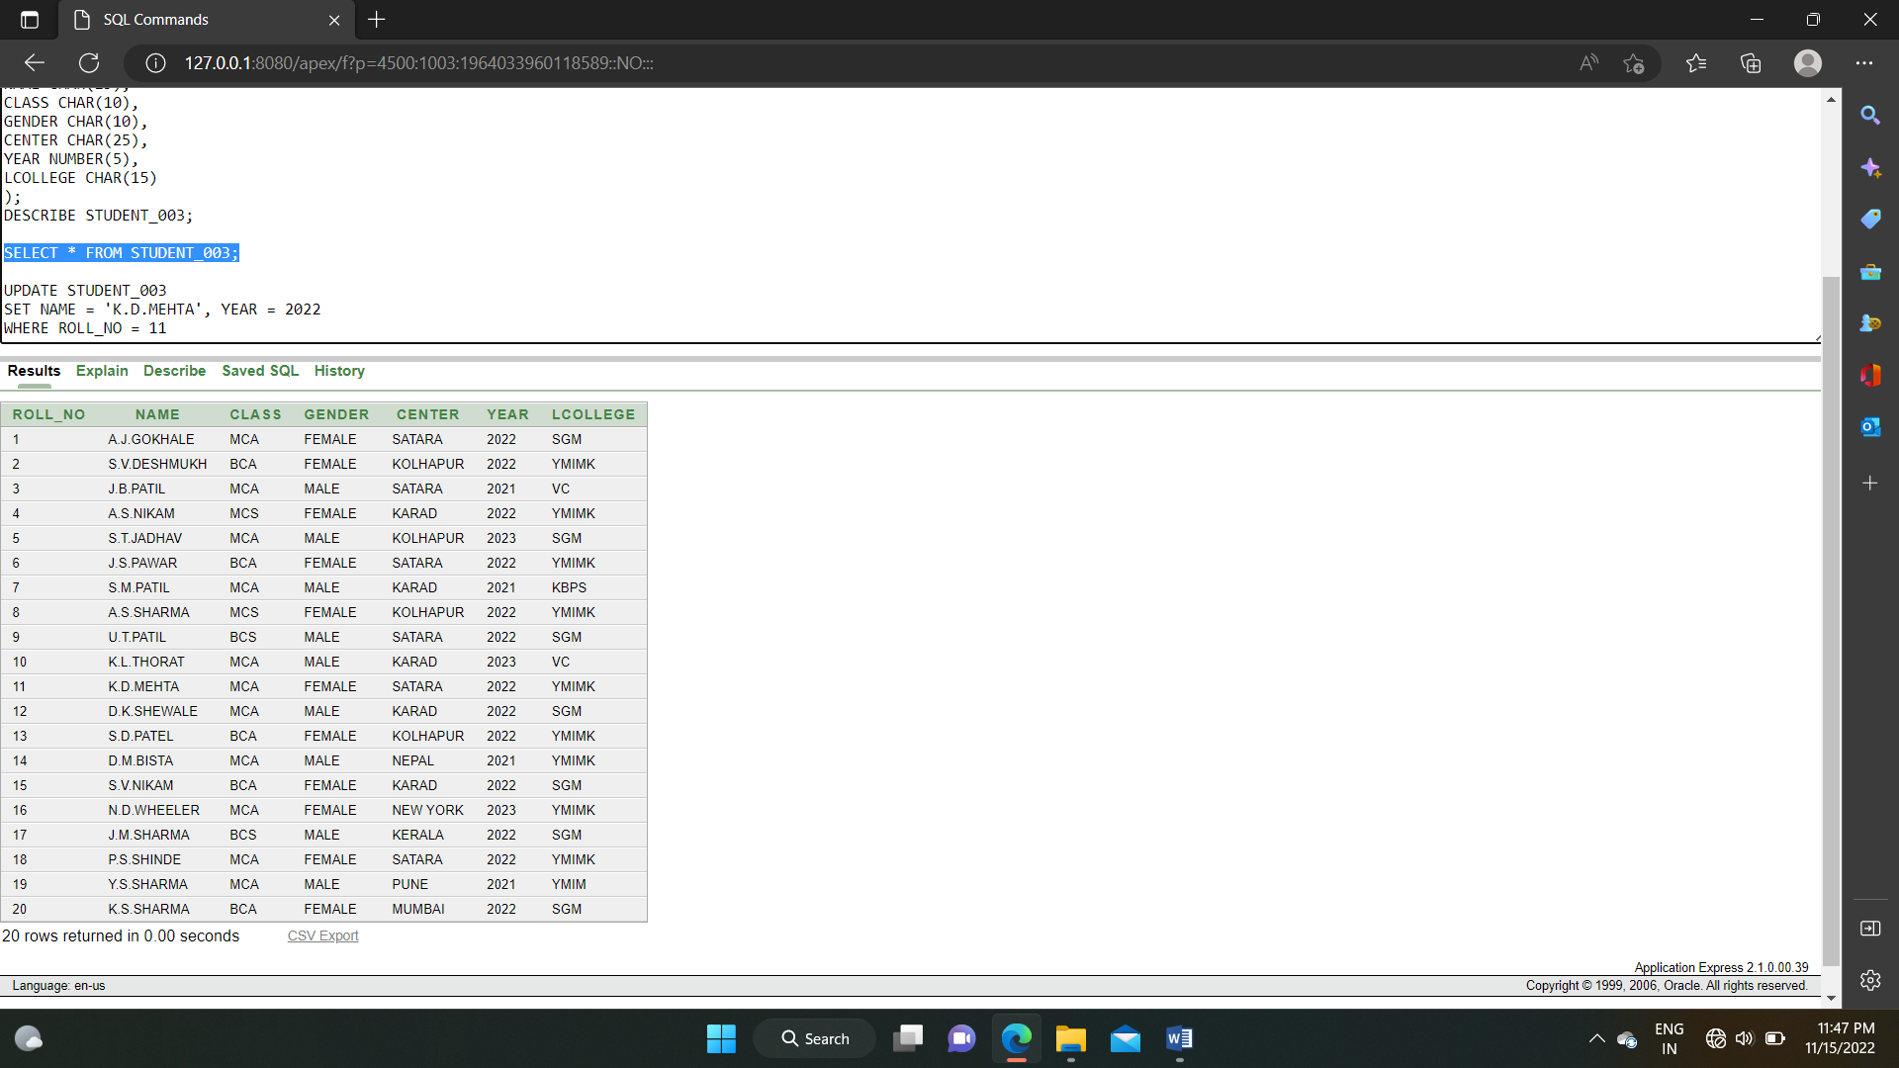

1. **DELETE** :

DELETE FROM STUDENT_003

WHERE ROLL_NO = 11

**OUTPUT :**

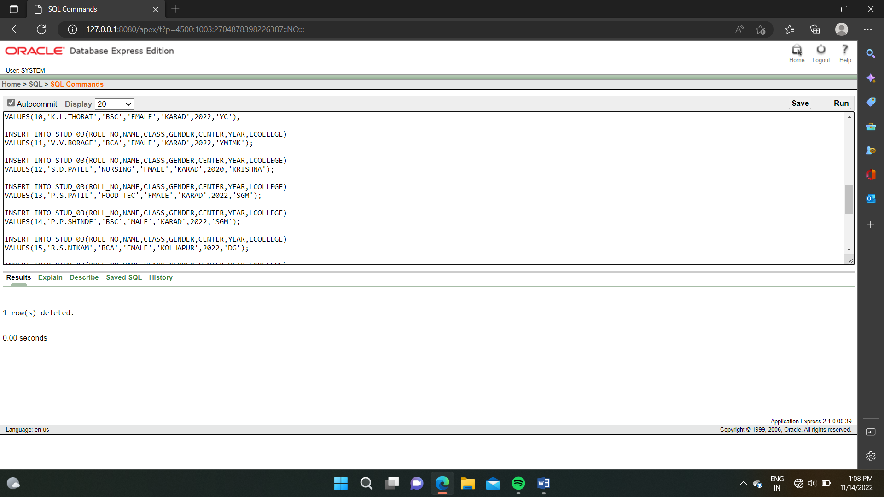

SELECT * FROM STUDENT_003

**OUTPUT :**

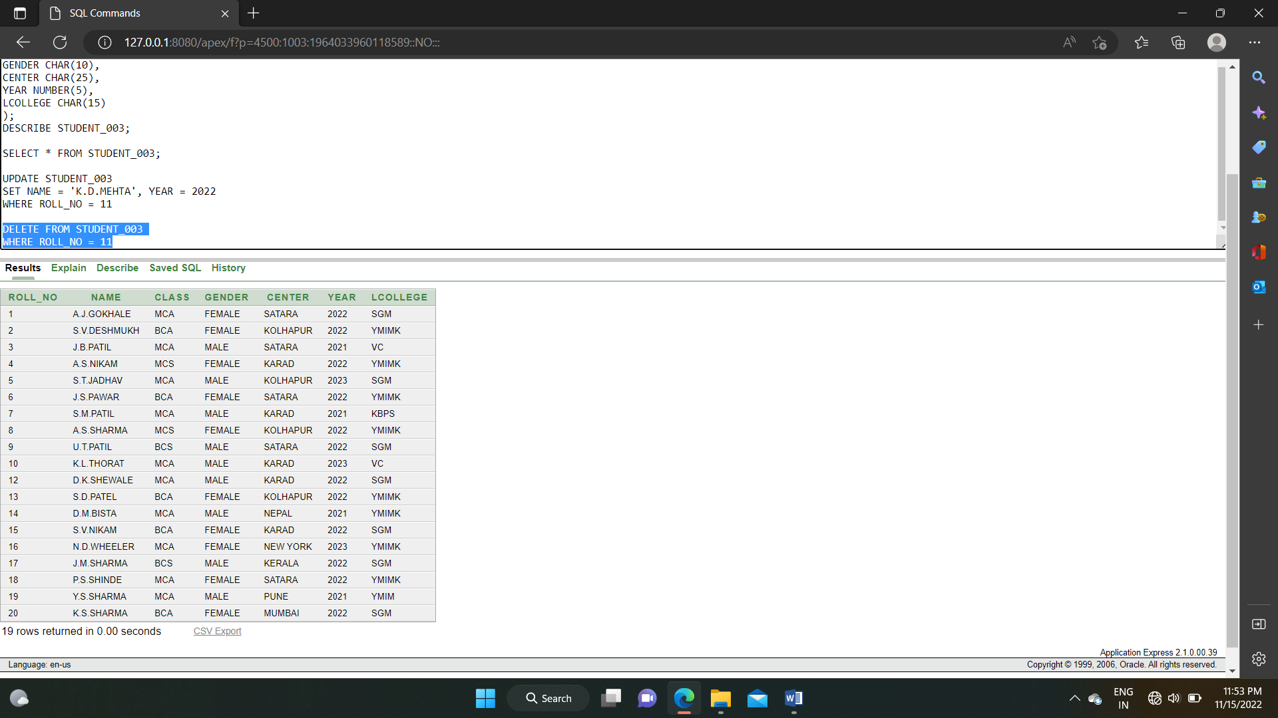

EXPERIMENT NO. 4

Write a SQL query using GROUP BY work in SQL.

i) MIN() ii) MAX() iii) COUNT iv) AVG() v) SUM()

1. **MIN()** :

SELECT MIN(ROLL_NO)

FROM (STUDENT_003)

WHERE CLASS='BCA';

**OUTPUT :**

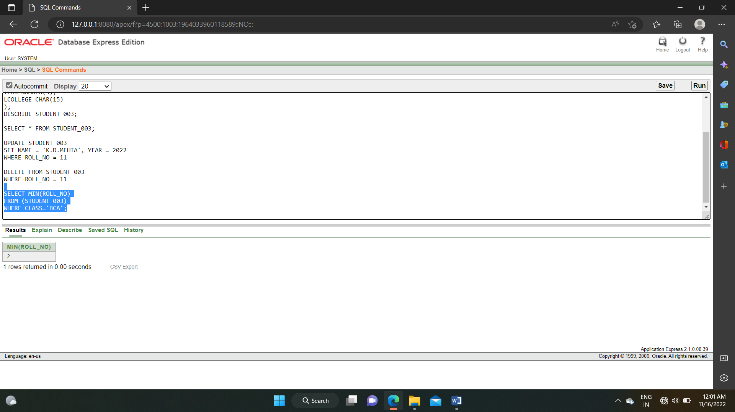

1. **MAX() :**

SELECT MAX(ROLL_NO)

FROM (STUDENT_003)

WHERE CLASS='BCA';

**OUTPUT :**

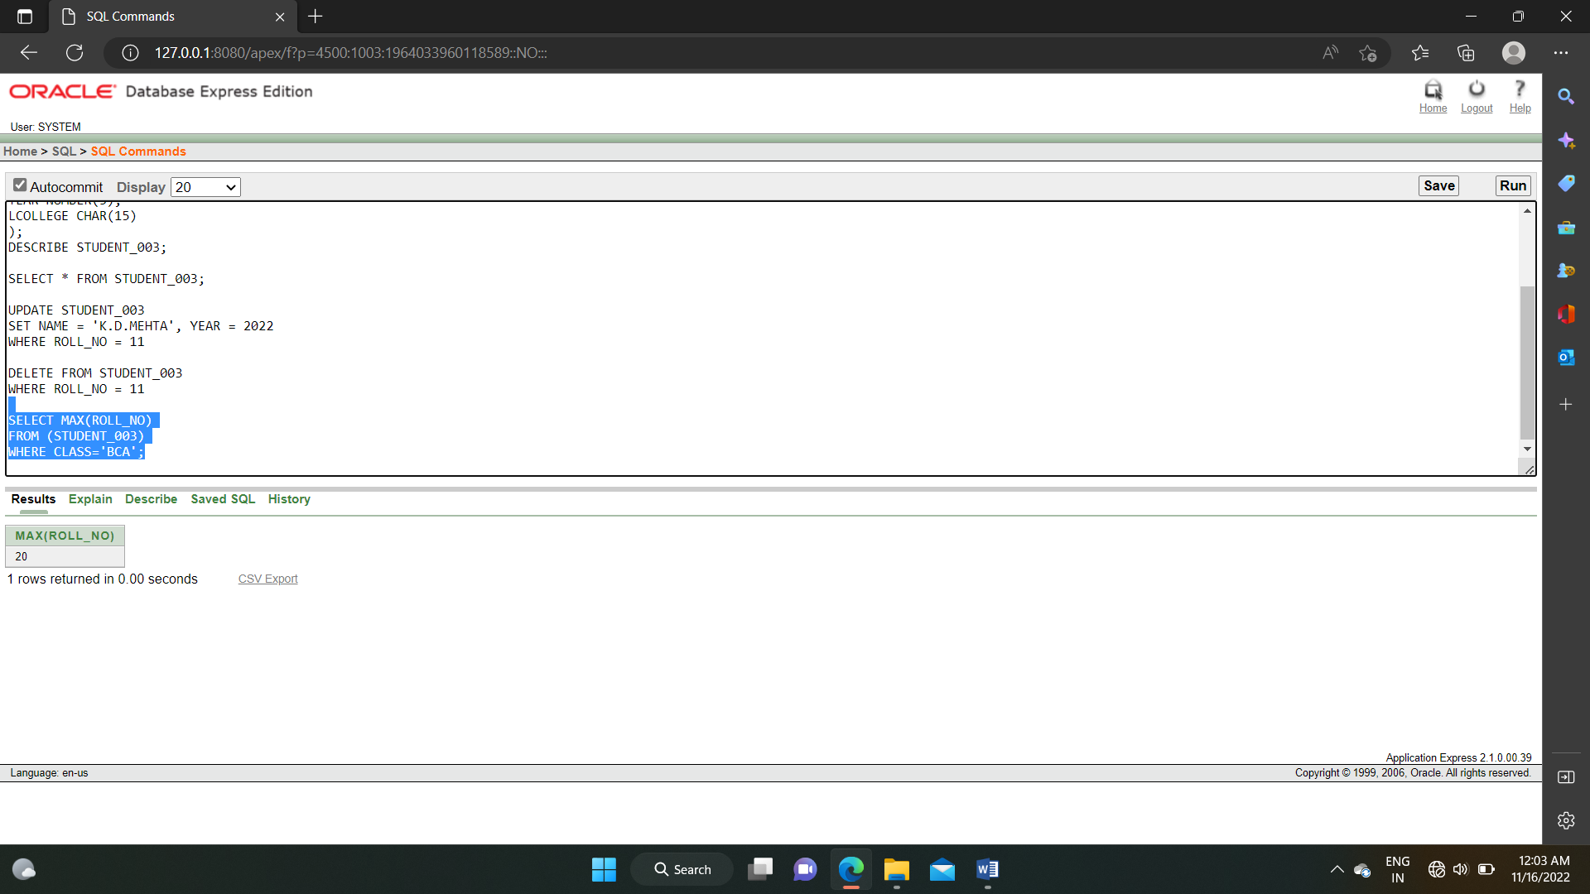

1. **COUNT() :**

SELECT COUNT(ROLL_NO)

FROM (STUDENT_003)

WHERE CLASS='MCA';

**OUTPUT :**

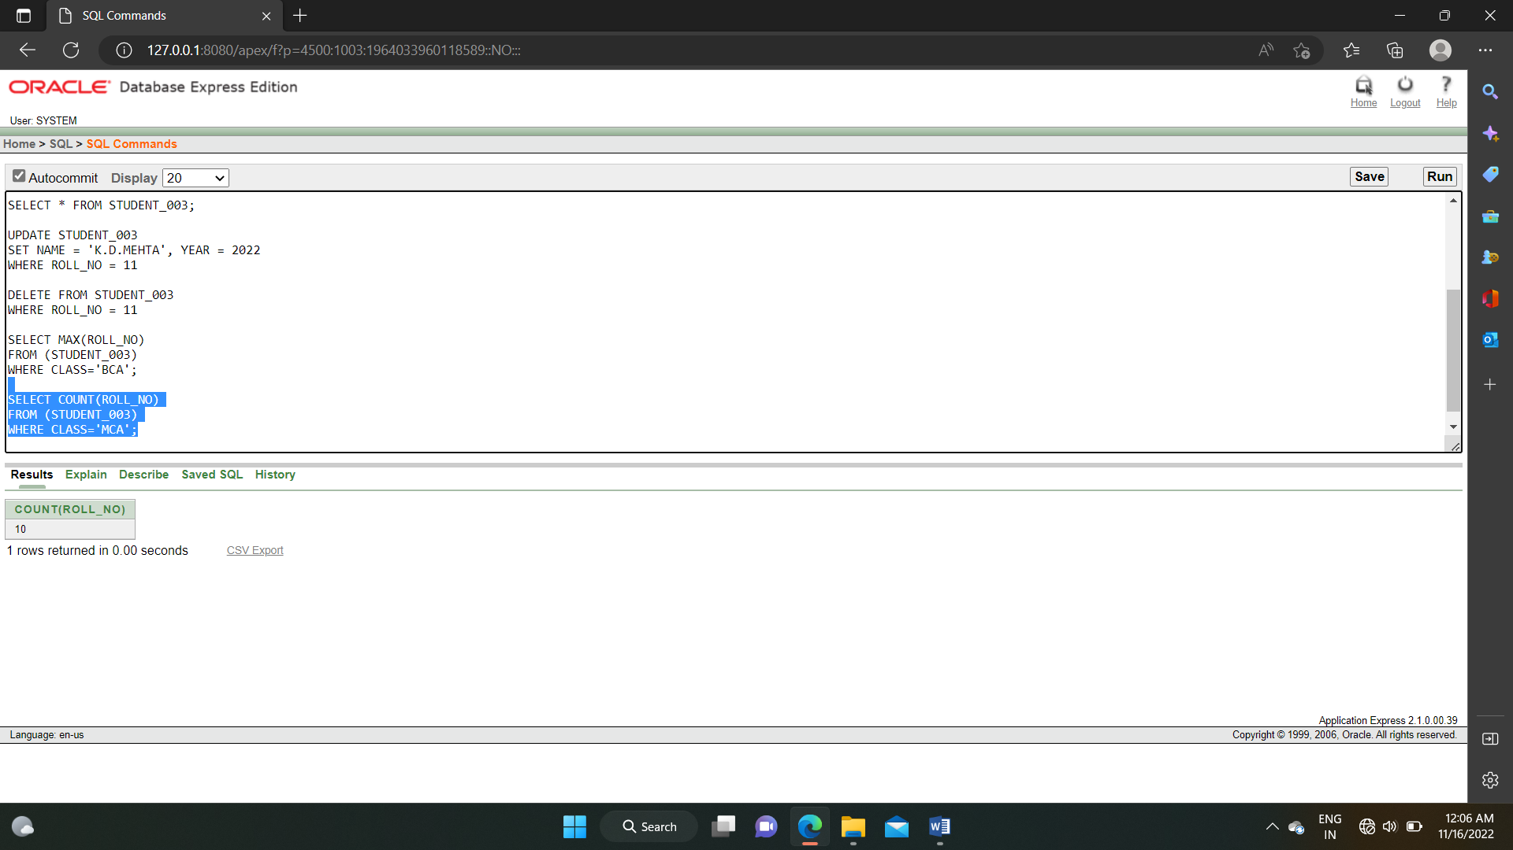

1. **AVG() :**

SELECT AVG(ROLL_NO)

FROM (STUDENT_003);

**OUTPUT :**

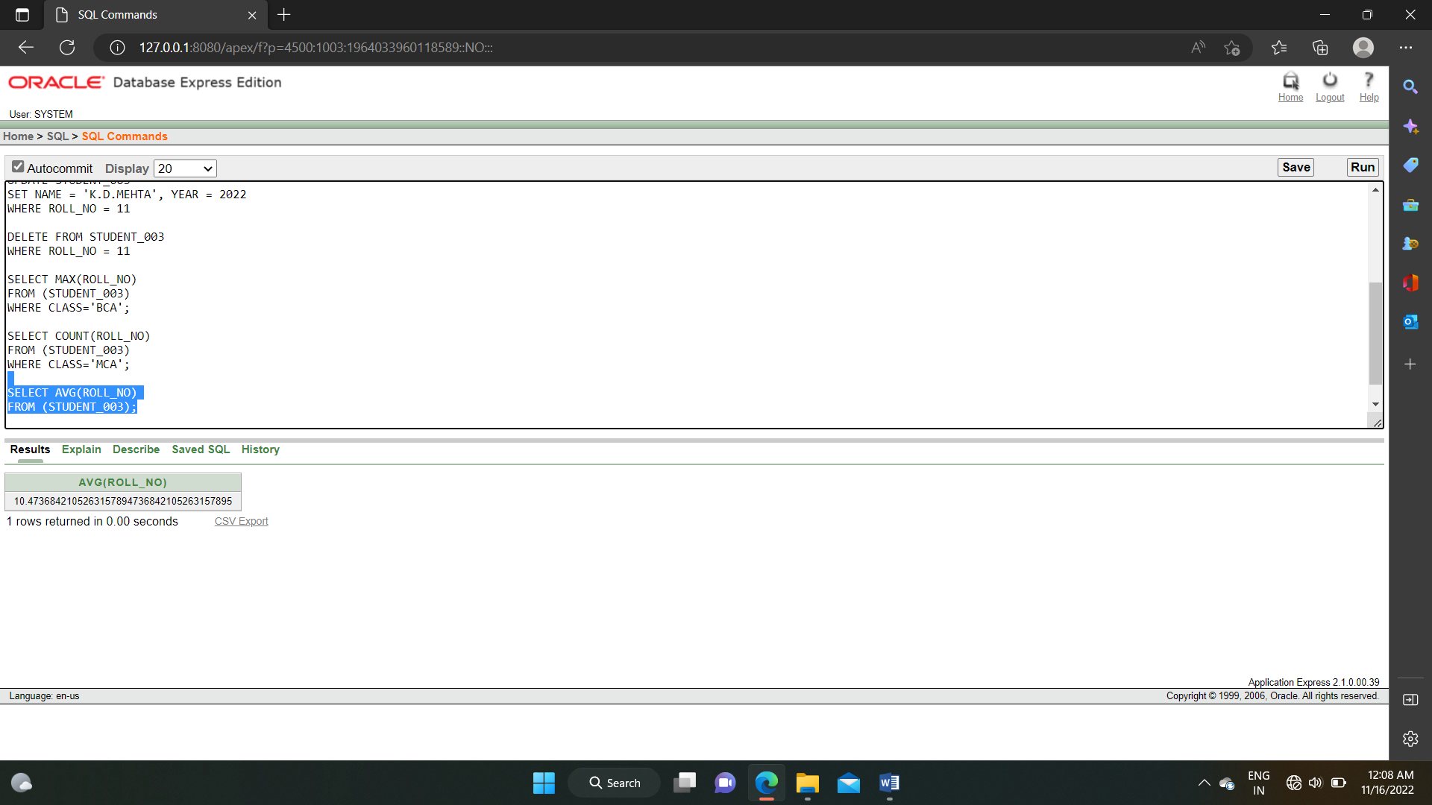

1. **SUM() :**

SELECT SUM(ROLL_NO)

FROM (STUDENT_003);

**OUTPUT :**

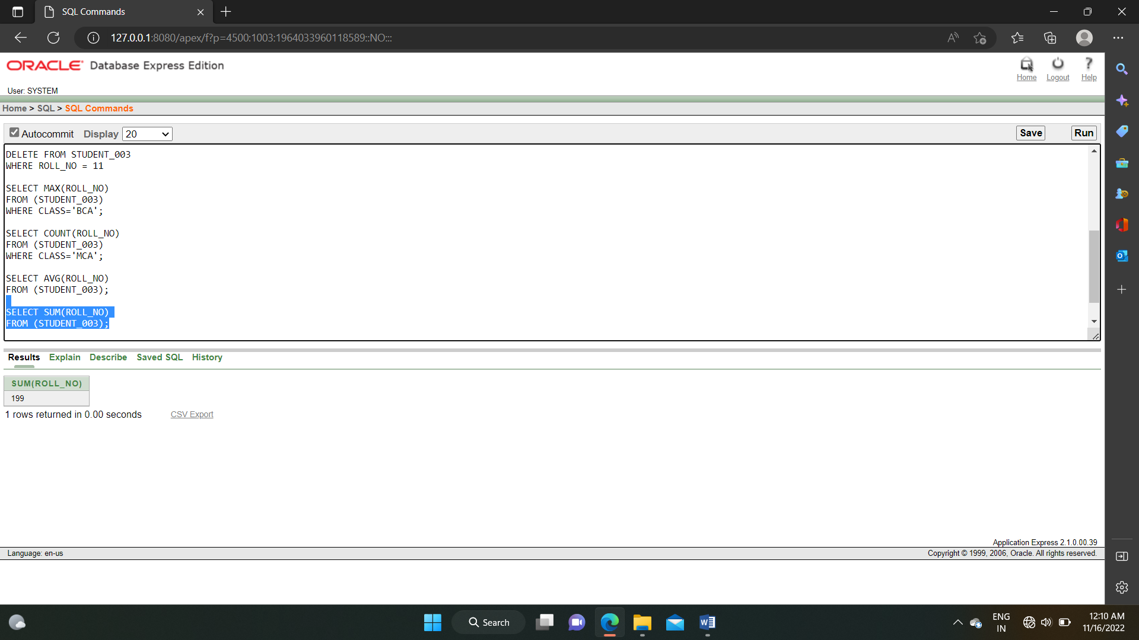

EXPERIMENT NO. 5

Write SQL subquery for STUDENT_003.

1. **SELECT :**

SELECT * FROM STUDENT_003

WHERE ROLL_NO IN (SELECT ROLL_NO)

FROM STUDENT_003

WHERE CLASS = 'MCA');

**OUTPUT :**

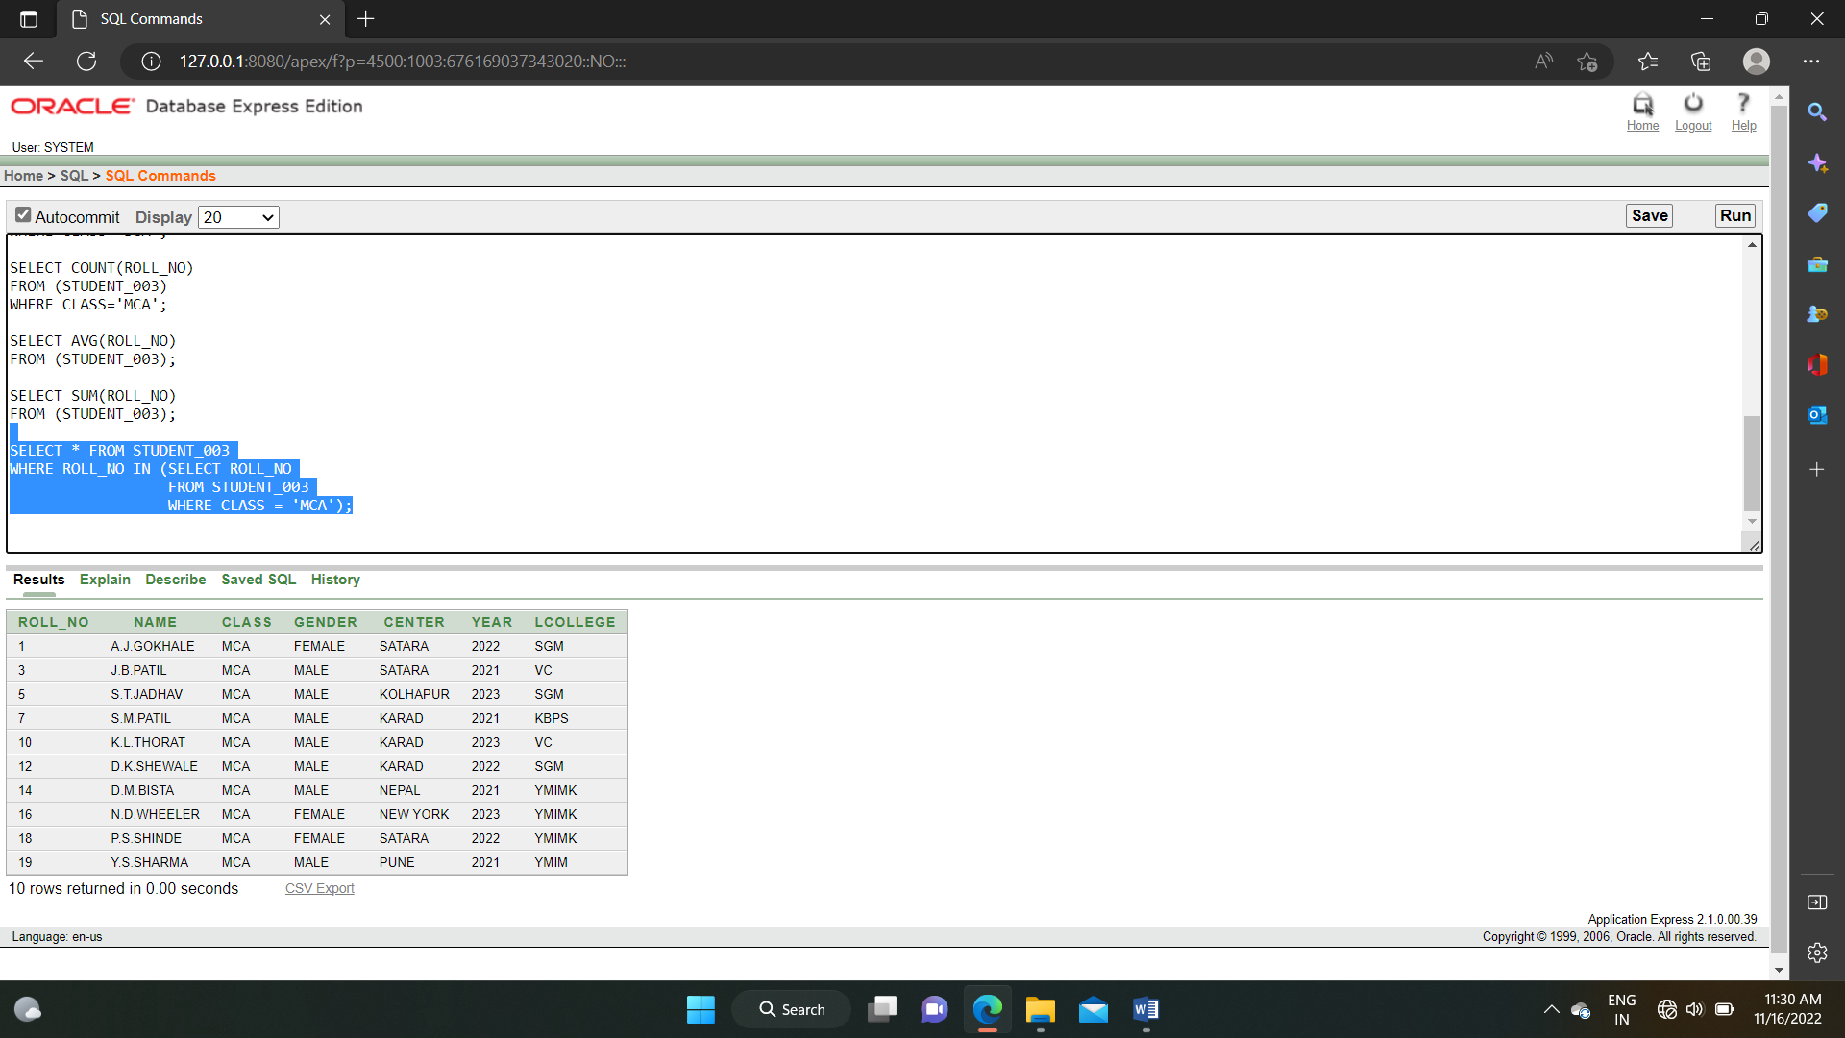

EXPERIMENT NO. 6

Write PL-SQL Block to print your ROLL_NO, NAME, CLASS.

DECLARE

NAME CHAR(30) := 'SHUBHAM';

ROLL_NO NUMBER(10) := 101;

CLASS CHAR(10) := 'MCA';

BEGIN

DBMS_OUTPUT.PUT_LINE('Your NAME is ='||NAME);

DBMS_OUTPUT.PUT_LINE('Your ROLL NUMBER is ='||ROLL_NO);

DBMS_OUTPUT.PUT_LINE('Your CLASS is ='||CLASS);

END;

/

**OUTPUT :**

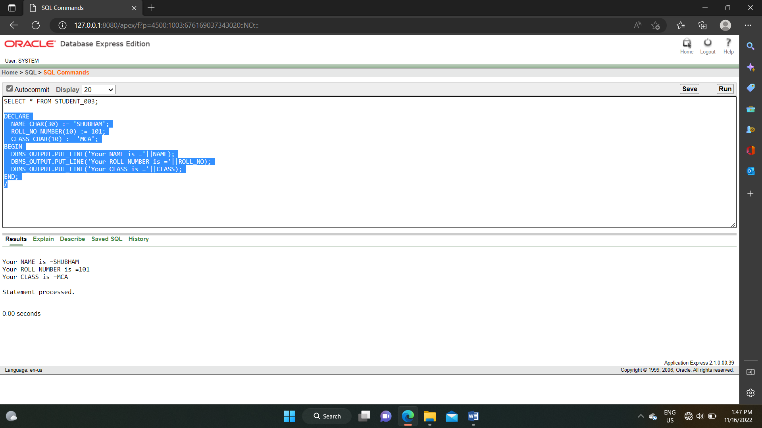

EXPERIMENT NO. 7

Write a PL-SQL by using a while loop to display all even number between 0 to 50 display the sum of numbers.

DECLARE

s number(10) := 0;

a number(2) := 2;

b number(2) := 4;

BEGIN

DBMS_OUTPUT.PUT_LINE('1 to 50 EVEN NUMBERS : ');

WHILE a < 50 LOOP

DBMS_OUTPUT.PUT_LINE(a);

a := a + 2;

s := s + a;

END LOOP;

DBMS_OUTPUT.PUT_LINE(' ');

DBMS_OUTPUT.PUT_LINE('Sum of 0 to 50 EVEN NUMBERS : '||s);

END;

/

**OUTPUT :**

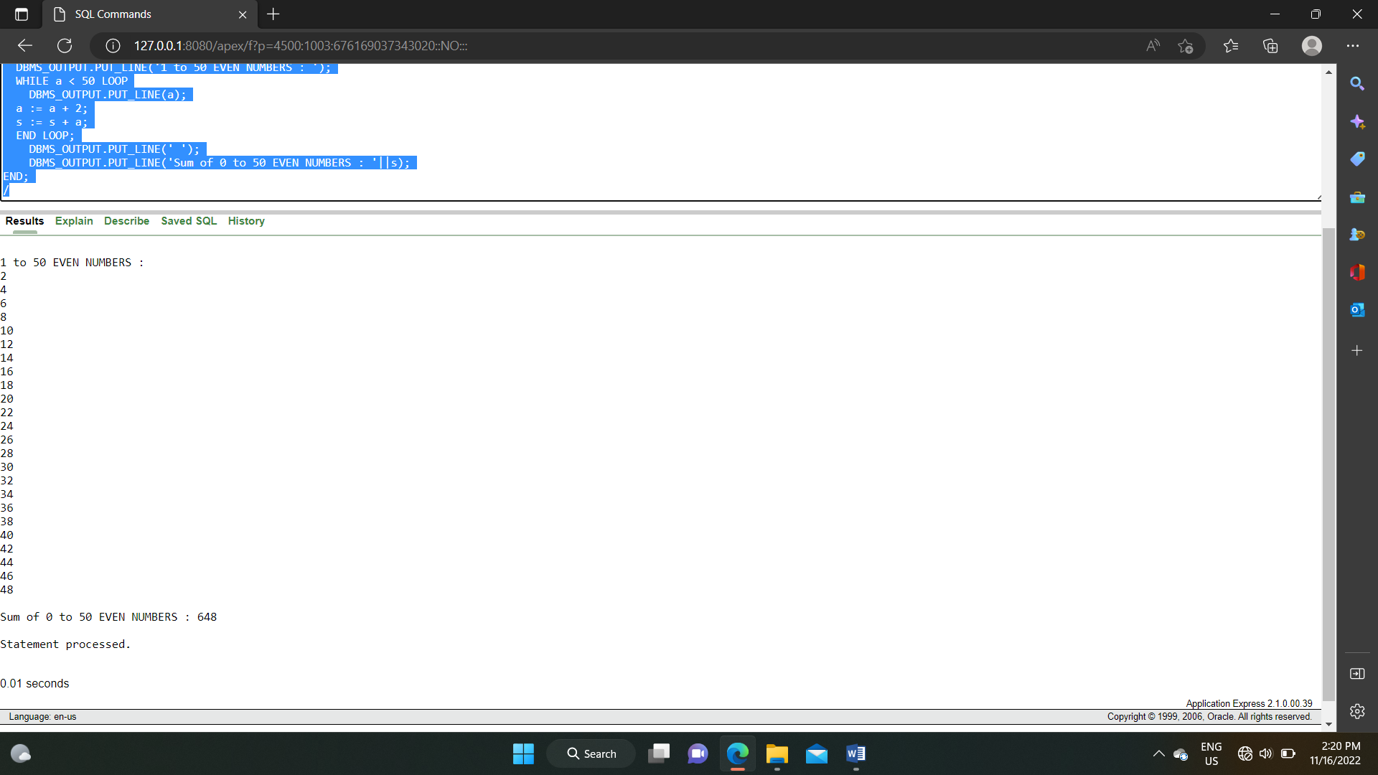

EXPERIMENT NO. 8

Write PL-SQL program by using if----- statement.

DECLARE

a NUMBER(3) := 20;

BEGIN

IF(a<30) THEN

DBMS_OUTPUT.PUT_LINE('a is less than 30');

ELSE

DBMS_OUTPUT.PUT_LINE('a is greater than 30');

END IF;

DBMS_OUTPUT.PUT_LINE('Value of a is : '||a);

END;

**OUTPUT :**

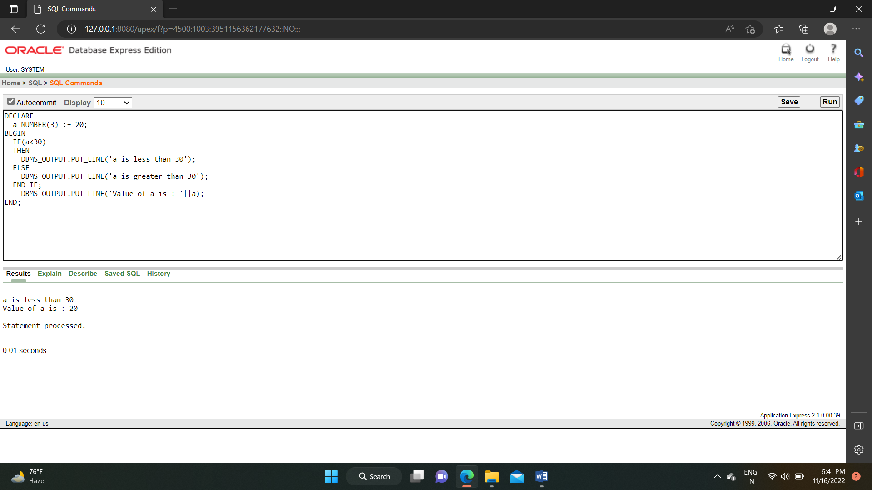

EXPERIMENT NO. 9

Write PL-SQL greeting of the days by using procedure.

CREATE OR REPLACE PROCEDURE greetings

AS

BEGIN

DBMS_OUTPUT.PUT_LINE('Good Morning..');

END;

/

**OUTPUT :**

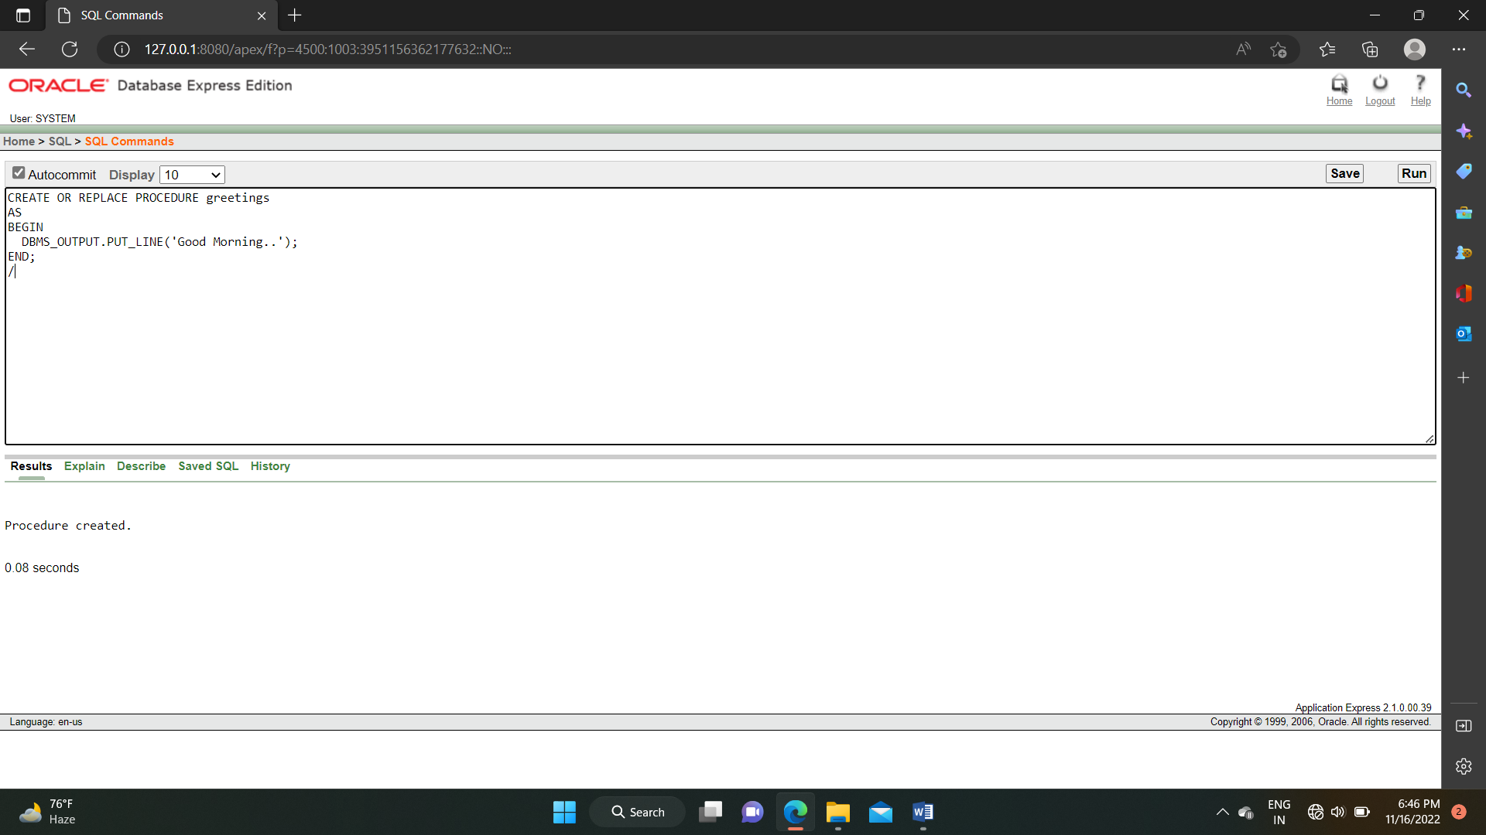

EXPERIMENT NO. 10

Write PL-SQL by using function to read 3 numbers and display the minimum amount then (or smaller).

DECLARE

a NUMBER := 20;

b NUMBER := 30;

c NUMBER := 40;

BEGIN

IF a<b AND a<c THEN

DBMS_OUTPUT.PUT_LINE('Smallest number is : '||a);

ELSIF b<a AND b<c THEN

DBMS_OUTPUT.PUT_LINE('Smallest number is : '||b);

ELSE

DBMS_OUTPUT.PUT_LINE('Smallest number is : '||c);

END IF;

END;

**OUTPUT :**

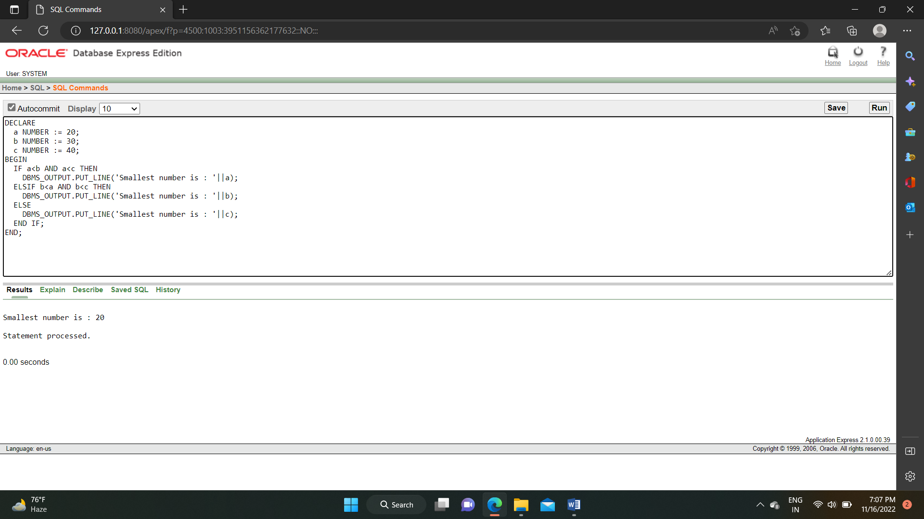

EXPERIMENT NO. 11

Write a PL-SQL to implement the cursor.

DECLARE

TOTAL_ROWS NUMBER(2);

BEGIN

UPDATE CUSTOMERS_003

SET SALARY = SALARY + 1000;

IF SQL%NOTFOUND THEN

DBMS_OUTPUT.PUT_LINE('No Customers Updated..');

ELSIF SQL%FOUND THEN

DBMS_OUTPUT.PUT_LINE('Customers Updated'||TOTAL_ROWS);

END IF;

END;

**OUTPUT :**

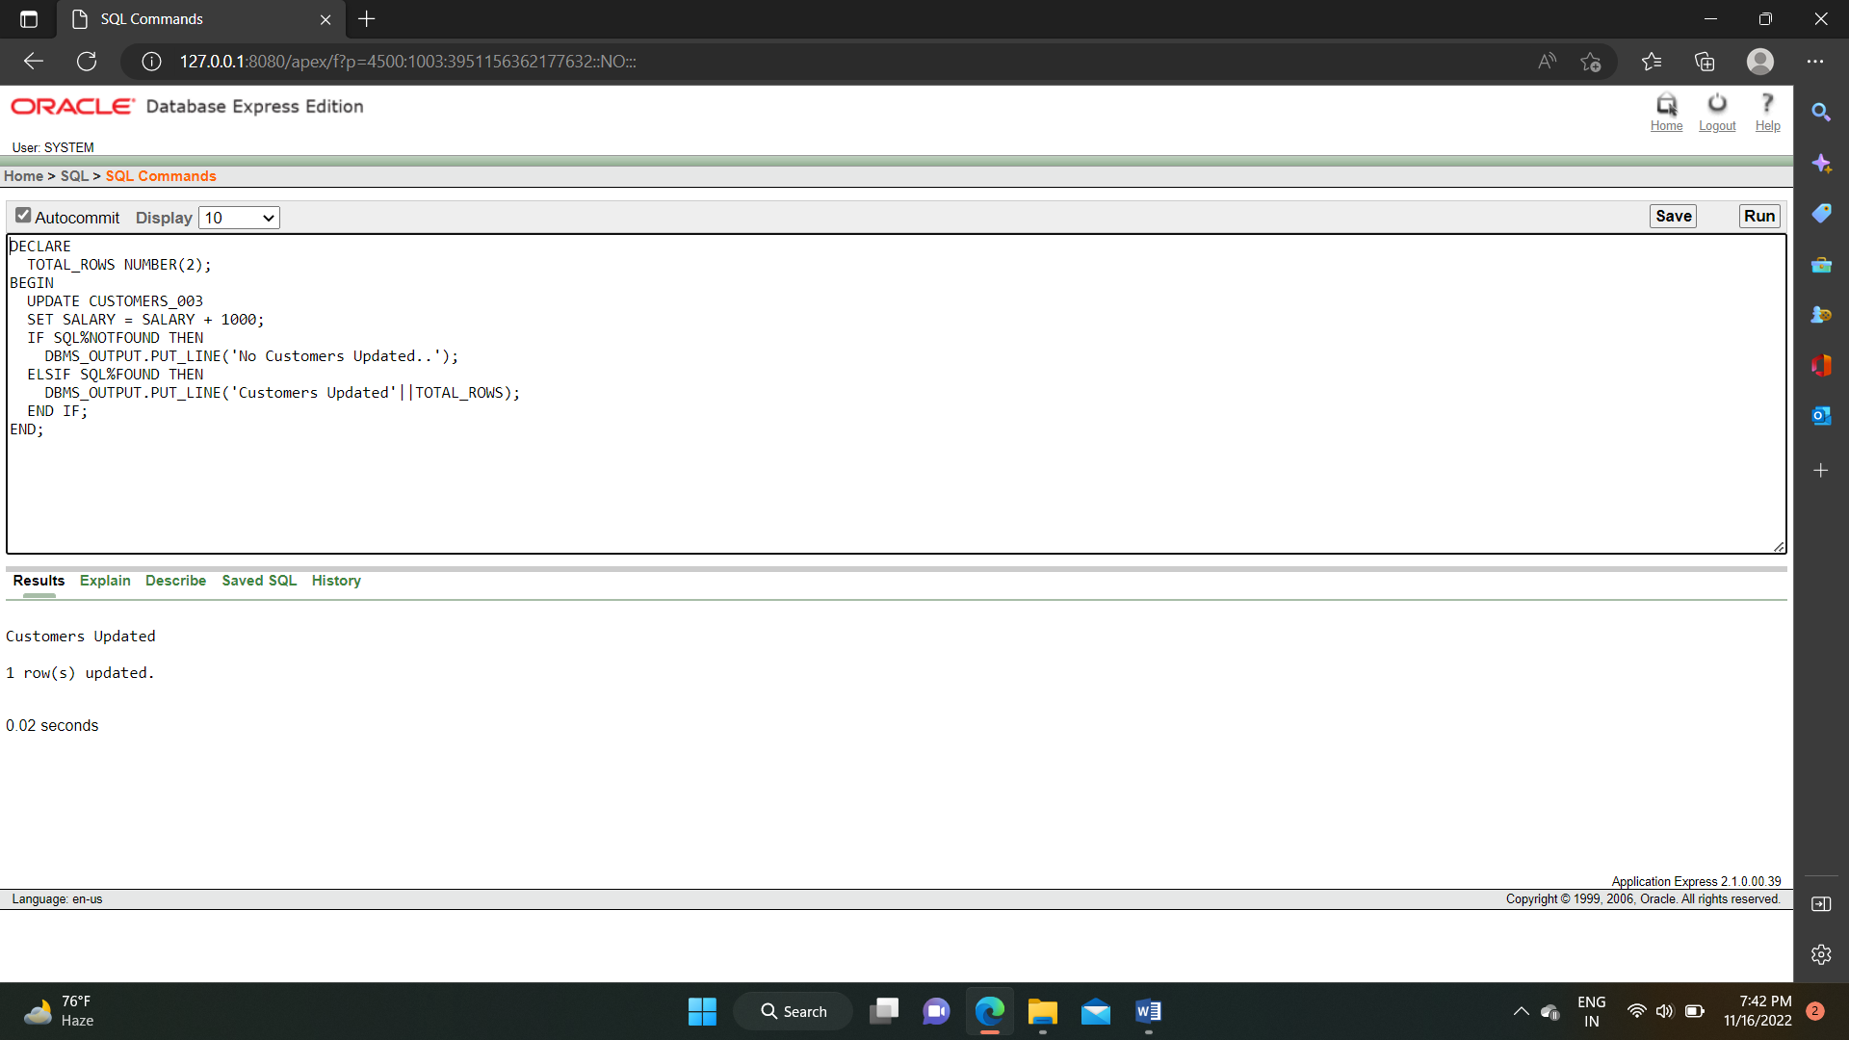

EXPERIMENT NO. 12

Write a PL-SQL to implement exception in PL-SQL.

DECLARE

C_ID CUSTOMERS_003.ID%TYPE := 10;

C_NAME CUSTOMERS_003.NAME%TYPE;

C_AGE CUSTOMERS_003.AGE%TYPE;

BEGIN

SELECT ID, NAME, AGE INTO C_ID, C_NAME, C_AGE FROM CUSTOMERS_003

WHERE ID = C_ID;

DBMS_OUTPUT.PUT_LINE('NAME : '||C_NAME);

DBMS_OUTPUT.PUT_LINE('AGE : '||C_AGE);

EXCEPTION

WHEN NO_DATA_FOUND THEN

DBMS_OUTPUT.PUT_LINE('NO SUCH CUSTOMER..');

WHEN OTHERS THEN

DBMS_OUTPUT.PUT_LINE('ERROR..');

END;

/

**OUTPUT :**

